Impact of income levels on the prevalence of delirium: A secondary analysis of the World Delirium Awareness and Quality Survey in 2023

Nobuto Nakanishi, MD¹, Kensuke Nakamura, MD, PhD², Kyohei Miyamoto, MD, PhD³, Kohei Ota, MD, PhD⁴, Shigeaki Inoue, MD, PhD^{5,6}, Giuseppe Bellelli, MD.^{7,8}, Julie Benbenishty, PhD⁹, Mark van den Boogaard, PhD, RN¹⁰, Gideon Caplan, MD, MB, FRACP, BS ^{11,12}, Chi Ryang Chung, MD¹³, Muhammed Elhadi, MD¹⁴, Mohan Gurjar, MD, PDCC, FICCM¹⁵, Gabriel Heras-La-Calle, MD^{16,17}, Magdalena Hoffmann, PhD, MSc, MBA, RN¹⁸, Marie-Madlen Jeitziner, PhD, RN¹⁹⁻²¹, Karla Krewulak, PhD²², Tanya Mailhot, PhD, RN²³, Alessandro Morandi, MD, MPH^{24,25}, Ricardo Kenji Nawa, PhD, PT, MSc²⁶, Esther S. Oh, MD, PhD²⁷, Marie O. Collet, PhD, RN²⁸, Maria Carolina Paulino, MD²⁹⁻³¹, Peter Nydahl, PhD, RN^{32,33*}, Heidi Lindroth, PhD, RN^{34,35}, Rebecca von Haken, MD³⁶, Keibun Liu, MD, PhD^{37,38,39}, and the WDAD Study Group.

Affiliations:
- Division of Disaster and Emergency Medicine, Department of Surgery Related, Kobe University Graduate School of Medicine, 7-5-2 Kusunoki, Chuo-ward, Kobe, 650-0017, Japan, nobuto_nakanishi@yahoo.co.jp
- Department of Critical Care Medicine, Yokohama City University Hospital 3-9 Fukuura, Kanazawa-ku, Yokohama, Kanagawa, 236-0004, Japan, mamashockpapashock@yahoo.co.jp
- Department of Emergency and Critical Care Medicine, Wakayama Medical University, 811-1 Kimiidera, Wakayama, Wakayama, 641-8509, Japan, go.go.kyohei.miyamoto@gmail.com
- Department of Emergency and Critical Care Medicine, Graduate School of Biomedical and Health Sciences, Hiroshima University, 1-2-3 Kasumi, Minami-ku, Hiroshima 734-8551, Japan, kota@hiroshima-u.ac.jp
- Department of Emergency and Critical Care Medicine, Wakayama Medical University, Wakayama, Japan, caf55000@gmail.com
- Emergency Medical Center, Wakayama Medical University Hospital, Wakayama, Japan
- School of Medicine and Surgery, Milano-Bicocca University, giuseppe.bellelli@unimib.it
- Acute Geriatric Unit, IRCCS San Gerardo Foundation, Monza, Italy
- Hebrew University Faculty of Medicine School of Nursing, Jerusalem, Israel, julie@hadassah.org.il
- Radboud University Medical Center, Department Intensive Care, Nijmegen, the Netherlands, Mark.vandenBoogaard@radboudumc.nl
- Department of Geriatric Medicine, Prince of Wales Hospital Sydney Australia, Gideon.Caplan@health.nsw.gov.au
- University of New South Wales, Sydney Australia
- Department of Critical Care Medicine and Medicine, Samsung Medical Center, Sungkyunkwan University School of Medicine, Seoul, South Korea, ccrzzang@gmail.com
- Faculty of Medicine, University of Tripoli, Tripoli, Libya, muhammed.elhadi.uot@gmail.com
- Department of Critical Care Medicine, Sanjay Gandhi Postgraduate Institute of Medical Sciences (SGPGIMS), Lucknow, India, m.gurjar@rediffmail.com
- Director of the International Research Project for the Humanization of Intensive Care Units (Proyecto HU-CI). Madrid. Spain, gabi@proyectohuci.com
- Intensive Care Unit. Hospital Universitario de Jaén. Spain, gabi@proyectohuci.com
- Research Unit for Safety and Sustainability in Healthcare, c/o Division of Plastic, Aesthetic and Reconstructive Surgery, Department of Surgery, Medical University of Graz, Graz, Austria, magdalena.hoffmann@medunigraz.at
- Department of Intensive Care Medicine, University Hospital Bern, marie-madlen.jeitziner@insel.ch
- Inselspital, University of Bern, Bern, Switzerland
- Institute of Nursing Science (I.N.S.), Department of Public Health (D.P.H.), Faculty of Medicine, University of Basel, Basel, Switzerland
- Department of Critical Care Medicine, Alberta Health Services & University of Calgary, Calgary, Alberta, Canada, kkrewula@ucalgary.ca
- Montreal Heart Institute Research Center, Faculty of Nursing, Université de Montréal, t.mailhot@umontreal.ca
- Intermediate Care and Rehabilitation, Azienda Speciale Cremona Solidale (Cremona, Italy), morandi.alessandro@gmail.com
- Parc Sanitari Per Vergili, Val d’Hebron Institute of Research (Barcelona, Spain)
- Hospital Israelita Albert Einstein, São Paulo, SP – Brazil, rkenji@hotmail.com
- Departments of Medicine, Psychiatry and Behavioral Sciences, and Pathology, Johns Hopkins University School of Medicine, eoh9@jhmi.edu
- Department of Intensive Care, Copenhagen University Hospital-Rigshospitalet, and Department of Clinical Medicine, Faculty of Health Sciences, University of Copenhagen, Denmark, marie.oxenboell-collet@regionh.dk
- Department of Intensive Care, Hospital da Luz Lisboa, Lisbon, Portugal, mcarolinapaulino@gmail.com
- NOVA Medical School, New University of Lisbon, Portugal;
- Department of Intensive Care, Hospital de São Francisco Xavier, CHLO, Lisbon, Portugal;
- Nursing Research, University Hospital Schleswig-Holstein, Kiel, Germany, Peter.Nydahl@uksh.de
- Institute of Nursing Science and Development, Paracelsus Medical University, Salzburg, Austria
- Division of Nursing Research, Department of Nursing, Mayo Clinic, Rochester, MN, U.S.A., Lindroth.Heidi@mayo.edu
- Center for Aging Research, Regenstrief Institute, School of Medicine, Indiana University, Indianapolis, IN, U.S.A.
- Department of Anesthesiology, GRN Gesundheitszentren Rhein-Neckar, Schwetzingen, Germany, Rebecca.vonHaken@grn.de
- Critical Care Research Group, The Prince Charles Hospital, Brisbane, QLD 4032, Australia, keiliu0406@gmail.com
- Institute for Molecular Bioscience, The University of Queensland, Brisbane, QLD 4006, Australia
- Non-Profit Organization ICU Collaboration Network (ICON), Tokyo, 113-0033, Japan

The list of supplemental materials:

Supplemental Figure 1. Flowchart of data included in the present study
Supplemental Figure 2. Visualization of non-high income and high income countries.
Supplemental Figure 3. Frequency of delirium prevalence
Supplemental Figure 4. Prevalence of delirium by the income level classification

Supplemental Table 1. Baseline characteristics
Supplemental Table 2. Delirium management practices

Supplemental Figure 1. Flowchart of data included in the present study
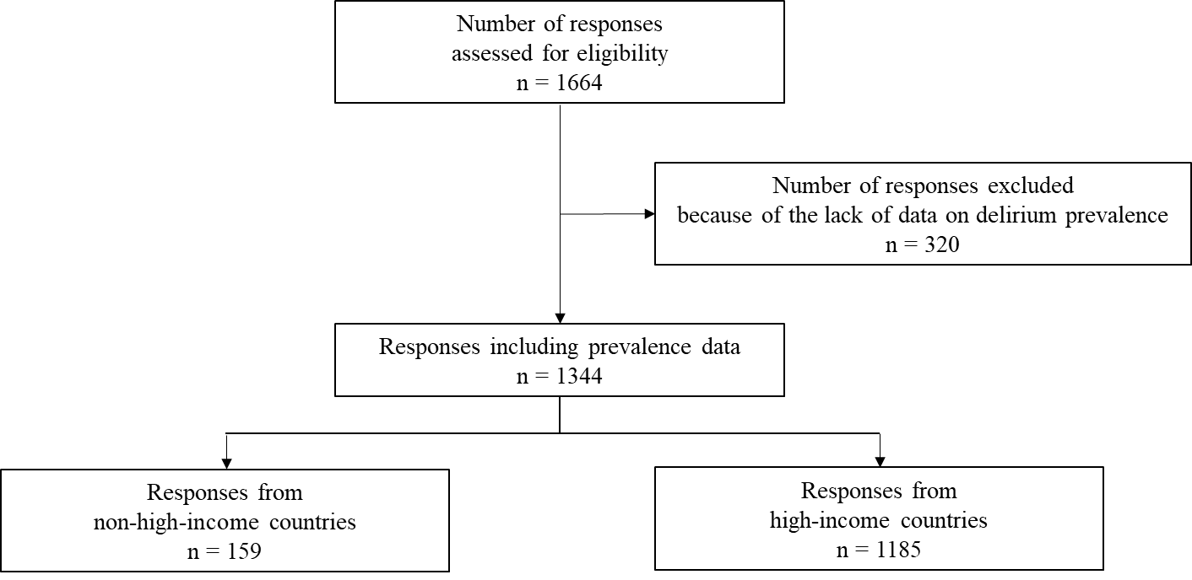

Supplemental Figure 2. Visualization of non-high income and high income countries.
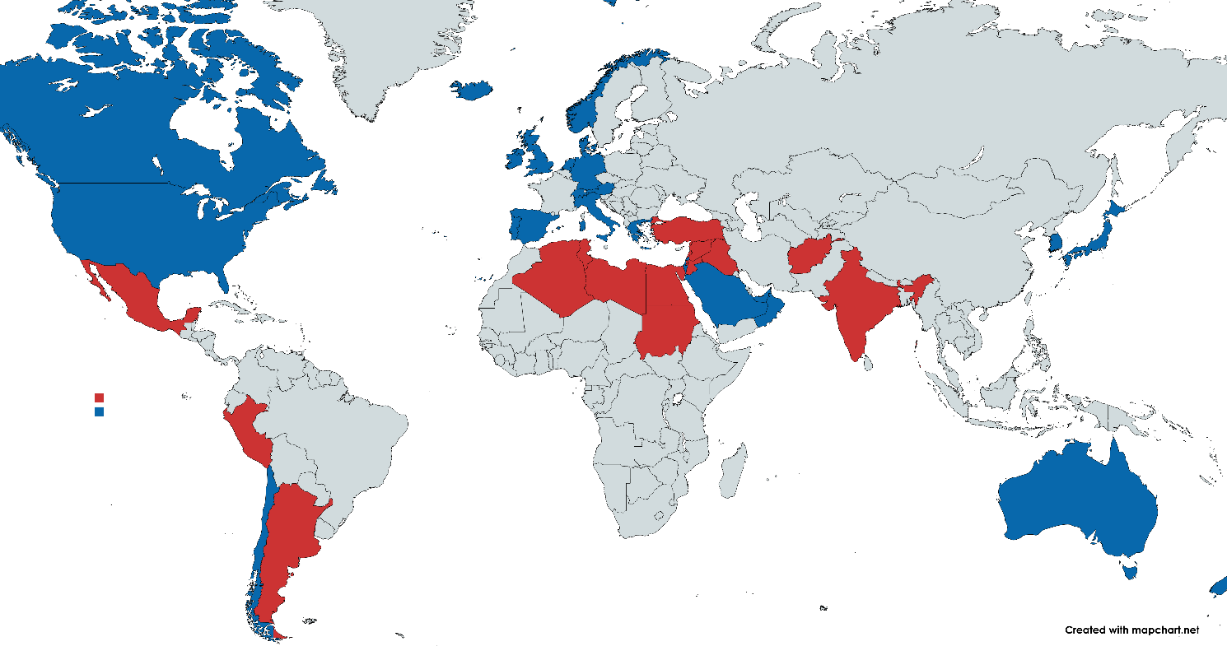

The income classification was based on the World Bank classification issued on 1 July 2022, using 2021 GNI per capita.
Red: non-high-income countries, Blue: high-income countries
The study included 41 countries. The 24 high-income countries were Australia, Austria, Canada, Chile, Denmark, Germany, Greece, Iceland, Ireland, Israel, Italy, Japan, the Netherlands, New Zealand, Norway, Oman, Portugal, Republic of Korea, Saudi Arabia, Spain, Switzerland, the United Arab Emirates, the United Kingdom of Great Britain and Northern Ireland, and the United States of America. The 17 non-high-income countries were Afghanistan, Algeria, Argentina, Egypt, Grenada, India, Iraq, Jordan, Lebanon, Libya, Mexico, Palestine, Peru, Sudan, the Syrian Arab Republic, Tunisia, and Turkey.
Map created with MapChart (mapchart.net).

Supplemental Figure 3. Frequency of delirium prevalence
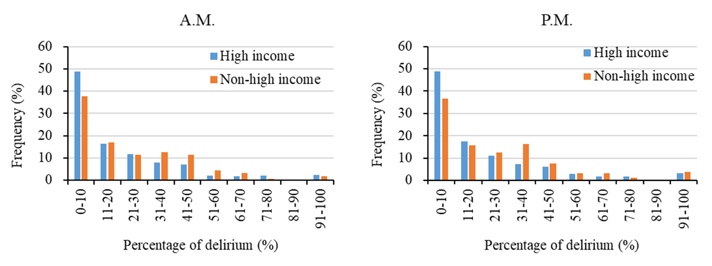
The frequency of delirium prevalence significantly differed between the non-high-income and high-income groups both in morning (p = 0.04) and evening (p < 0.01).

Supplemental Figure 4. Prevalence of delirium by the income level classification
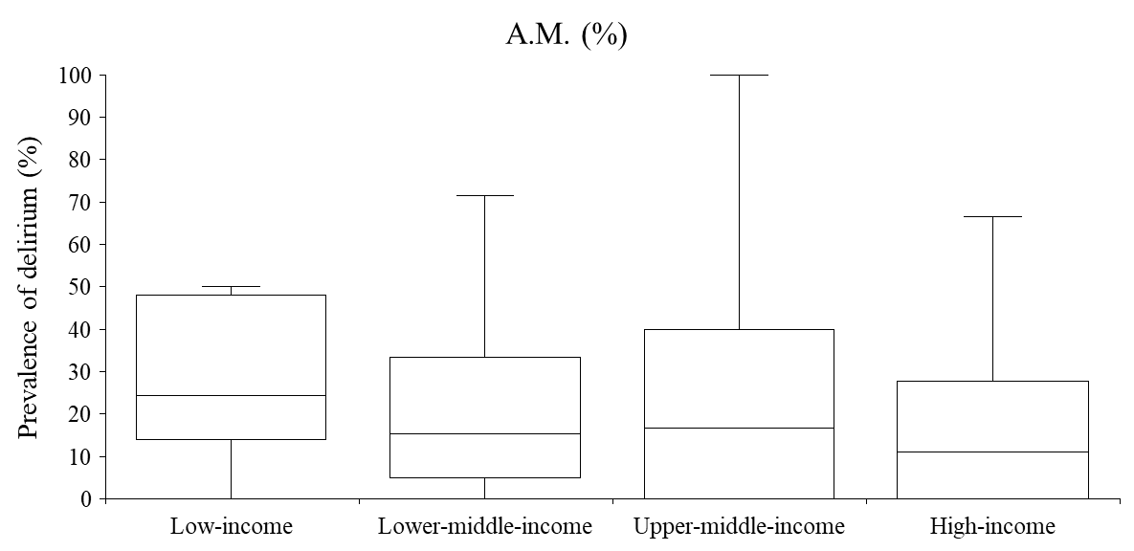

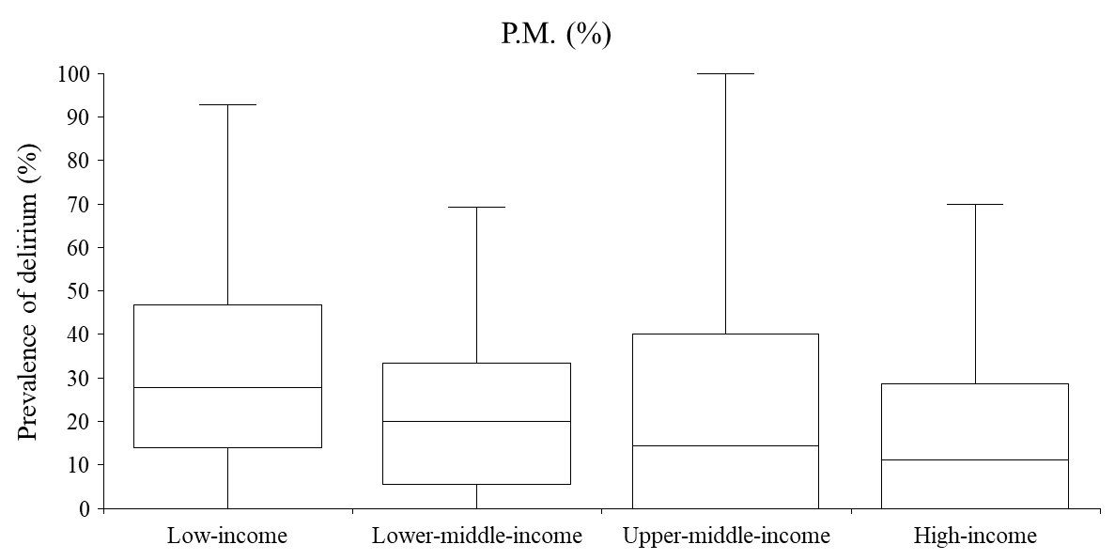
The number of responses, with one response representing one ward or one ICU of a hospital included in the analysis, was 20 for the low-income, 76 for the lower-middle, 63 for the upper-middle, and 1185 for the high-income classification.

Supplemental Table 1. Baseline characteristics
 | Non-high-income  n = 159 | High-income  n = 1185 | p-value
Continent*
Asia | 60 (37.7) | 60 (5.1) | <0.01
Australia | 0 (0) | 216 (18.2) | <0.01
Africa | 72 (45.3) | 0 (0) | <0.01
Europe | 5 (3.1) | 798 (67.3) | <0.01
South America | 20 (12.6) | 1 (0.1) | <0.01
North America | 2 (1.3) | 110 (9.3) | <0.01
Age (years)
0-17 | 5 (3.1) | 43 (3.6) | <0.01
18-75 | 128 (80.5) | 656 (55.4) | <0.01
>75 | 1 (0.6) | 227 (19.2) | <0.01
Mixed | 25 (15.7) | 256 (21.6) | <0.01
Hospital type
University | 72 (45.3) | 512 (43.2) | <0.01
University-related | 19 (12.0) | 323 (27.3) | <0.01
Community | 24 (15.1) | 222 (18.7) | <0.01
Nursing home | 0 (0) | 7 (0.6) | <0.01
Rehabilitation center | 0 (0) | 28 (2.4) | <0.01
Private hospital | 41 (25.8) | 29 (2.5) | <0.01
Other | 2 (1.3) | 62 (5.2) | <0.01
Hospital bed
<250 | 59 (37.1) | 162 (13.7) | <0.01
<500 | 28 (17.6) | 299 (25.2) | <0.01
<750 | 15 (9.4) | 267 (22.5) | <0.01
<1000 | 26 (16.4) | 225 (19.0) | <0.01
<1500 | 19 (12.0) | 104 (8.8) | <0.01
≥1500 | 12 (7.6) | 128 (10.8) | <0.01
Data in the table are presented as numbers (percentage)
* The study included 41 countries. The 14 Asian countries were Afghanistan, India, Iraq, Israel, Japan, Jordan, Lebanon, Oman, Palestine, the Republic of Korea, Saudi Arabia, the Syrian Arab Republic, Turkey, and the United Arab Emirates. The two Oceanian countries were Australia and New Zealand. The five African countries were Algeria, Egypt, Libya, Sudan, and Tunisia. The 13 European countries were Austria, Denmark, Germany, Greece, Iceland, Ireland, Italy, the Netherlands, Norway, Portugal, Spain, Switzerland, and the United Kingdom of Great Britain and Northern Ireland. The three South American countries were Argentina, Chile, and Peru. The four North American countries were Canada, Grenada, Mexico, and the United States of America.

Supplemental Table 2. Delirium management practices
 | Non-high-income  n = 159 | High-income  n = 1185 | p-value
Primary assessing profession in this survey
Nurse | 14 (8.8) | 788 (66.5) | <0.01
Physician | 84 (52.8) | 149 (12.6) | <0.01
Psychiatrist | 13 (8.2) | 12 (1.0) | <0.01
Mixed professions | 30 (18.9) | 168 (14.2) | <0.01
Frequency of delirium assessments
Once per day (24h) | 43 (27.0) | 161 (13.6) | <0.01
Twice per day (24h) | 21 (13.2) | 229 (19.3) | <0.01
Thrice per day (24h) | 8 (5.0) | 218 (18.4) | <0.01
More than thrice per day (24h) | 3 (1.9) | 50 (4.2) | <0.01
Only at admission | 12 (7.6) | 45 (3.8) | <0.01
Only with a sudden change in consciousness | 65 (40.9) | 289 (24.4) | <0.01
Presence of protocols*,#
Pain management (assess, prevent, and manage pain) | 101 (63.5) | 972 (82.0) | <0.01
Spontaneous awakening trial (SAT) management | 37 (23.3) | 179 (15.1) | 0.01
Spontaneous breathing trial (SBT) management | 56 (35.2) | 219 (18.5) | <0.01
Sedation management | 65 (40.9) | 483 (40.8) | 0.98
Delirium management (assess, prevent, and manage delirium) | 59 (37.1) | 861 (72.7) | <0.01
Dementia | 16 (10.1) | 272 (23.0) | <0.01
Mobility and exercise | 43 (27.0) | 618 (52.2) | <0.01
Family engagement and empowerment | 24 (15.1) | 342 (28.9) | <0.01
Nutrition management | 71 (44.7) | 729 (61.5) | <0.01
Sleep | 20 (12.6) | 190 (16.0) | 0.26
Physical restraints | 35 (22.0) | 542 (45.7) | <0.01
ICU diaries | 33 (20.8) | 140 (11.8) | <0.01
Practice for delirium awareness*
At least one educational training session on delirium in the last year | 59 (37.1) | 630 (53.2) | <0.01
Delirium flyer for the staff | 13 (8.2) | 342 (28.9) | <0.01
Delirium is mentioned in handovers | 60 (37.7) | 786 (66.3) | <0.01
Pocket cards for delirium assessment/management | 9 (5.7) | 256 (21.6) | <0.01
Informational posters on delirium | 21 (13.2) | 373 (31.5) | <0.01
Delirium experts, known by the team and dedicated to delirium care | 14 (8.8) | 421 (35.5) | <0.01
Communication of the delirium screening rate | 24 (15.1) | 379 (32.0) | <0.01
Data in the table are presented as numbers (percentage)
*Multiple choices were allowed in the survey
# The implementation of the ABCDEF bundle as a complete bundle was not assessed. Individual protocols corresponding to several components of the ABCDEF bundle were assessed separately.

