Supplementary Files
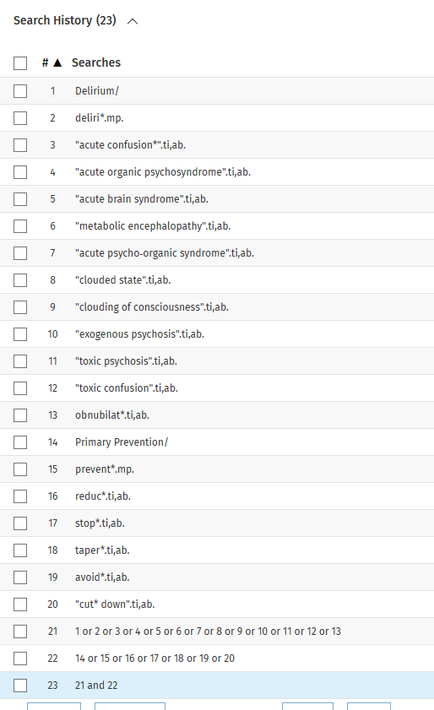
Supplementary File 1.

Figure S1. Medline search strategy

Supplementary File 2.
Table S1. Study design according to TIDieR items
TIDieR Item | Caplan et al. (2006, Australia) (26) | Isaia et al. (2009, Italy) (27) | Verloo et al. (2015 & 2016, Switzerland) (24, 25)
1. Intervention Name | The REACH-OUT Trial: Hospital in the Home (HitH) – a post-acute rehabilitation model providing early discharge with home-based multidisciplinary care. | Geriatric Home Hospitalisation Service (GHHS) – a “hospital-at-home” care model offering early discharge with substitutive geriatric and multidisciplinary care at home. | Patient-centred, nurse-led delirium detection and prevention intervention (the nurse-led intervention) – a structured, home-based delirium prevention nursing program following hospital discharge.
2. Why (Rationale) | Hospitalisation for older adults with frailty increases delirium risk due to environmental and physiological stressors. The study tested whether home rehabilitation reduced delirium incidence compared with standard inpatient rehabilitation. | Hospitalisation for older adults with frailty increases risk of delirium due to environmental stress, immobilisation, and iatrogenic factors. Prior RCTs (including Caplan 2006) suggested fewer delirium episodes with home-based interventions. The study evaluated whether GHHS, by replicating hospital-level care at home, could reduce delirium and adverse outcomes. | Delirium is common and often undetected among older adults post-hospitalisation, leading to cognitive and functional decline, rehospitalisation, and mortality. The study estimated the effect of an innovative nursing intervention to detect and/or to prevent delirium among discharged older adults receiving home health care compared to usual home care.
3. What (Materials) | HitH involved provision of physiotherapy tools, mobility aids, and medical equipment as required. Rehabilitation materials were supplied free for up to three months. | GHHS provided medical equipment in the home, as needed, and non-pharmacological delirium prevention supports such as orientation boards (with names, clocks, calendars), relaxation materials (warm drinks, music), cognitive activities (word games etc.), and hydration and nutrition aids (oral care supplies, small frequent meals). | The nurse-led intervention provided non-pharmacological delirium prevention supports including orientation aids (clocks, calendars, clear signage), safety and mobility aids (handrails, adjusted home layouts), hydration and nutrition materials (bottles, reminders to hydrate, meal coordination), sensory aids (glasses, hearing aids), and printed educational leaflets for participants and carers. A structured user guide outlined 15 nursing protocols across six domains.
4. What (Procedures) | HitH participants were visited daily for the duration of rehabilitation by multidisciplinary rehabilitation staff. The intervention emphasised early mobility, delirium risk reduction, shared-care management, and education. | GHHS participants received three sessions per day by multidisciplinary home-based care for the duration of rehabilitation. Non-pharmacological strategies to prevent and manage delirium were applied. Not all components were delivered at each session. | The first home visit, conducted within 48 hours of consent, included reassessment of delirium symptoms (CAM), evaluation functional status (ADL/IADL), and vital signs (glycaemia, blood pressure, heart rate, pain, oxygen saturation, temperature). If delirium symptoms were present or patient condition worsened, the geriatric clinical nurse (GCN) provided reassurance, education, and written materials to the participant and carer, and, when necessary, advised contacting a general practitioner (GP).  Five structured home visits during study period, covering seven domains: assessment, detection, monitoring, support, direct care, health promotion, and education. The intervention was guided by a structured manual comprising 15 nursing-specific protocols and approximately 70 nursing activities.
5. Who Provided | A multidisciplinary outreach team (nurses, physiotherapists, occupational therapists, doctors) experienced in hospital-at-home models since 1989. | A geriatric multidisciplinary team (3 geriatricians, 13 nurses, 2 physiotherapists, 1 social worker, 1 counsellor). | One GCN delivered all visits, trained over 3 days by the PI in delirium recognition (CAM), risk assessment, and protocol use.
6. How (Mode of Delivery) | The intervention was delivered face-to-face in patients’ homes by outreach staff. | The intervention was delivered face-to-face by multidisciplinary team in patients’ homes. | The intervention was delivered face-to-face by the GCN. Intervention adapted to patient context using structured guide.
7. Where (Location) | Participants received HitH in their private homes. | Participants received GHHS in their private homes. | Participants received the nurse-led intervention in their private homes.
8. When and How Much (Dose) | Daily visits for the duration of rehabilitation phase with a mean of 20 visits over a mean period of 15.97±9.37 days. | Three visits per day for the duration of rehabilitation (mean 19±9.5 days). Not all program components were offered at each visit. Mobility was offered three times per day and environmental modifications to prevent cognitive deprivation were offered twice per day. The remaining components were offered once per day. | Five structured home visits at 48 hours, 72 hours, 7, 14, 21 days post-hospital discharge, lasting 30-60 minutes per session (91% completed full schedule)
9. Tailoring | Rehabilitation plans adjusted to functional capacity. | Plans adapted to each patient’s functional, nutritional, and cognitive status. | Each visit was personalised to participant risk profile (hydration, sleep, pain, nutrition). The user guide standardised delivery while allowing individual adaptation.
10. Modifications | None reported. | None reported. | No modifications during trial; intervention refined during pretesting with five participants to ensure feasibility and clarity.
11. How Well (Planned Fidelity) | Fidelity was supported through assessor training, inter-rater reliability testing, and use of validated instruments (CAM, FIM, MMSE, GDS). The CAM was administered every second day to ensure consistent monitoring. Assessors were blinded at baseline but unblinded thereafter due to treatment setting. Ethical oversight and a stakeholder committee maintained trial quality and procedural fidelity. | Fidelity was supported through use of standardised and validated instruments (CAM, MMSE, DRS, ADL/IADL, MNA, GDS), systematic 48-hour reassessments, and data collection by experienced physicians (≥5 years’ experience in research interviews) uninvolved in the intervention. Ethical approval and informed consent procedures reinforced methodological rigour. Although assessors were unaware of study aims, they were not blinded to treatment setting, introducing a potential source of bias. | Fidelity was ensured through a structured user guide, expert-reviewed and pre-tested protocols, targeted training of the GCN, and ongoing supervision by the principal investigator (PI). Inter-rater reliability between the PI and GCN was high across outcome measures (CAM κ = 0.79; ADL/IADL κ = 0.85; MMSE ICC = 0.92). Both the PI and GCN were blinded to group allocation and prior assessment results to minimise measurement bias.
12. How Well (Actual Fidelity) | Adherence to HitH was confirmed via daily logs and multidisciplinary coordination. HitH maintained prescribed staffing ratios and included all planned daily sessions. The CAM was administered every second day, demonstrating protocol consistency. | Standardised assessments were consistently implemented. Non-pharmacological delirium-prevention protocols were applied.  All planned follow-ups were completed with systematic outcome measurement. | All participants in the nurse-led arm received the full sequence of five structured home visits within one month. A total of 244 patient-centred interventions were delivered to 51 participants (mean 5 interventions each). Each visit followed 15 standardised nursing protocols, verified via nurse logs and PI supervision. Intervention durations (5–180 minutes) were documented, and fidelity monitoring occurred throughout. Inter-rater agreement data (CAM κ = 0.79; MMSE ICC = 0.92; ADL/IADL κ = 0.85) confirmed adherence to assessment protocols. Participant adherence was strong, with low attrition and high acceptability at 1-month follow-up.
Nb: ADL – Activities of Daily Living; CAM – Confusions Assessment Method; DRS – Delirium Rating Scale; FIM – Functional Indepenadnce Measure; GCN - geriatric clinical nurse; GDS – Geriatric Depression Scale; GHHS – Geriatric Home Hospitalisation Service; GP – general practitioner; HitH – Hospital in the Home; IADL – Instrumental Activities of Daily Living; ICC – Intraclass Correlation Coefficient; k – Cohen’s kapper; MMSE – Mini-mental State Examination; MNA – Mini Nutritional Assessment; RCT – randomised controlled trial.

